Using the Farm

# Deployment: (Readme file in source code)

If using truffle you can simply put your secrets in a file named **secrets.json** then excute

truffle migrate --network bsc

# Funding the Farm:

1. Go to The DXS page on BSC scan [here](https://bscscan.com/token/0xB0Df5519F460E96117C12Ea667557b161866189c) and approve the farm to spend DXS.

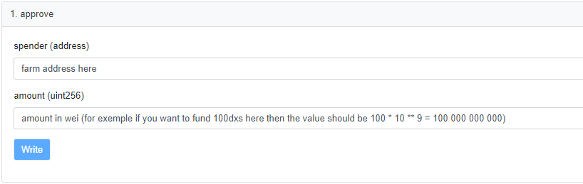

1. Call the fund function with the amount you approved in step 1

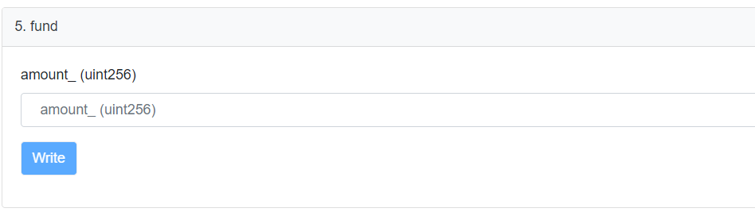

* Keep in mind that the amount is in wei, so always * 10 * DECIMALS
* Funding the Farm can be done at any time before the end block, and every time the farm is funded the end block will be pushed to the future according to this formula endtime = starttime + funding/rewardsPerSecond.

# Creating the Pools:

To create a pool call the add Pool Function:

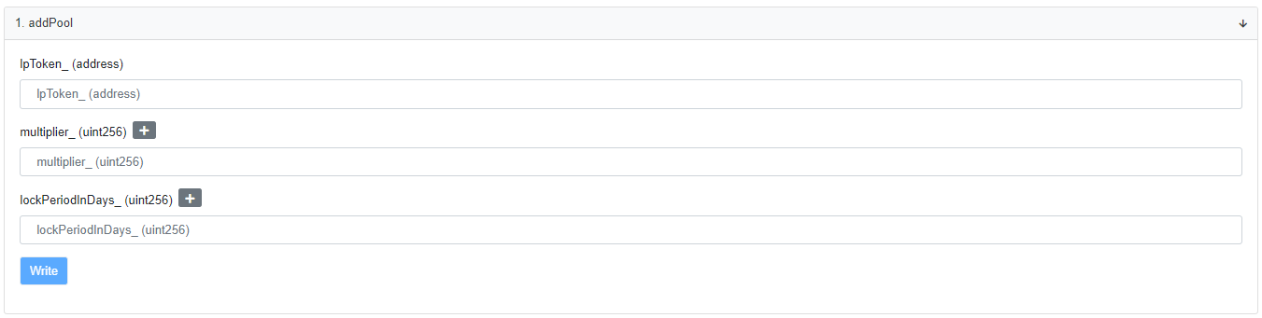

**Arguments**:

**multipllier_:** **multipllier** points this will dictate how each reward per block will be distributed between pools so the rewards per pool are calculated as follow (PoolRewardsPerBlock = rewardsPerBlock * **multipllier** / Total **multipllier**s)

**lpToken_:** the address of the token staked in this pool

**lockedPeriodInDays_:** the lock period in days (set to zero for no lock)

* The front is configured to have 3 farms, if you want to add more farms please add them to the front too, look in /src/ web3Utils/ farmConfigs.js for more details